**HLCV EXERCISE 3 REPORT**

**AKSHAY JOSHI**

**2581346**

**s8akjosh@stud.uni-saarland.de**

**ANKIT AGRAWAL**

**2581532**

**s8anagra@stud.uni-saarland.de**

**SUSHMITA NAIR**

**2581308**

**s8sunair@stud.uni-saarland.de**

**Question 1: Implement Convolutional Network**

1. **Report the training and validation accuracies**

We have used **Kaiming Weight Initialization** method considering the ReLu activation used in the network. Because of this we have achieved slightly better results compared to Random Weight Init.

Validation Accuracy: **81.0 %**

Accuracy of the network on the 1000 test images: **81.69999999999999 %**

Plots to show the Accuracies & Loss of this model:

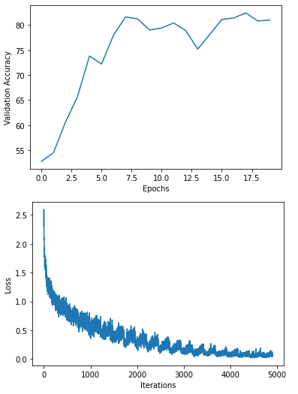

1. **Report the number of trainable parameters of the model**

Number of trainable parameters = 7682826

1. **Visualize & compare the filters before and after training**

**Before:**

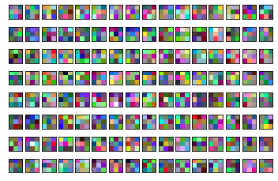

**After:**

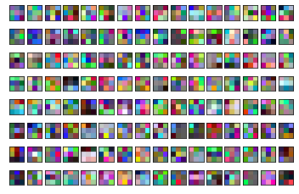

It can be noticed that the filters after the network training process have slightly changed based on certain conditions/regions of the image on which our kernel/filter passes through.

Some colors from the input are more pronounced and picked over other (Light intensity -> Dark in the output) and vice versa. Though it is sad that we can’t understand/see much about the edge detection or fine features detected by the network.

**Question 4: Use pre-trained networks**

1. **Validation and testing accuracies of Pre-trained Model:**

Validation Accuracy: **64.8%**

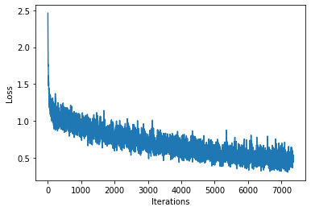

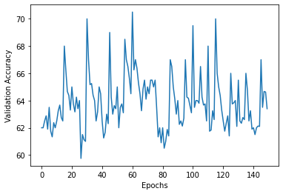

1. **Compare the two models training curves, validation and testing performance**

Please find the accuracy metrics for Model 2 (Fine-tuned) and Model 3 (Trained from scratch)

**Test:**

Accuracy of the best pre-trained network (using Early stopping) on the 1000 test images: **89.5 %**

Accuracy of the network with weights from random init on the 1000 test images: **88.9 %**

**Validation:**

Accuracy of the best pre-trained network (using Early stopping) on the 1000 test images: **89.9 %**

Accuracy of the network with weights from random init on the 1000 test images: **89.1 %**

It appears that the fine-tuned model is slightly out-performing the model which was trained from scratch in both Test and Validation accuracies

**Model 2:**

Test:

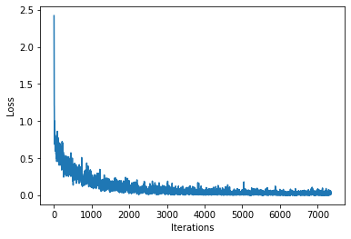

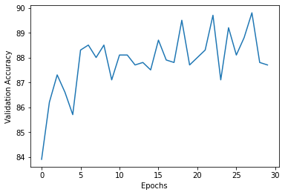

**Val:**

